Module 4(Task 3)

Task A (Set): Update a specific book to change its price to 19.99.
in my audio collection I didn’t create price field now using $set I added price field and also set 19.99 price as per question

db.audio_book.updateOne(
{ Title: "Can't Hurt Me Vol 1" },
{ $set: { price: 19.99 } }
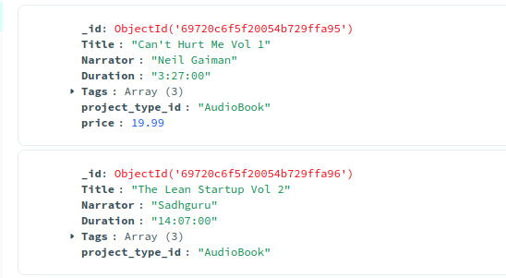
)

in this Query, it will update all Sadhguru AudioBook Price to 19.99

db.audio_book.updateMany(
{ Narrator: "Sadhguru" },
{ $set: { price: 19.99 } }
);
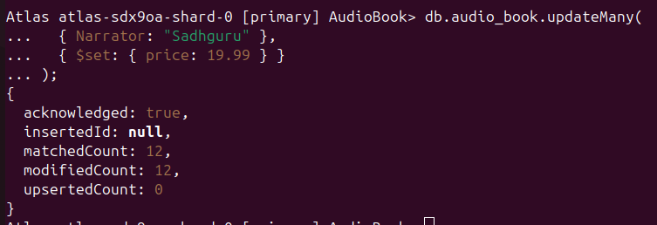

Task B (Push Array): Add a new tag "Best-seller" to the existing Tags array for a specific book.

Here I update Tag column
I added Best-seller tag in Tag column using $push as per question

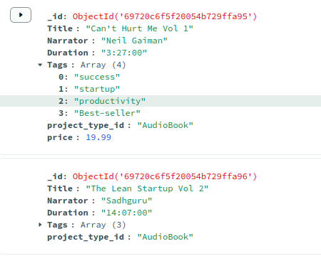

db.audio_book.updateOne(
{ Title: "The Subtle Art Vol 3" },
{ $push: { Languages: "Hindi" } }
);

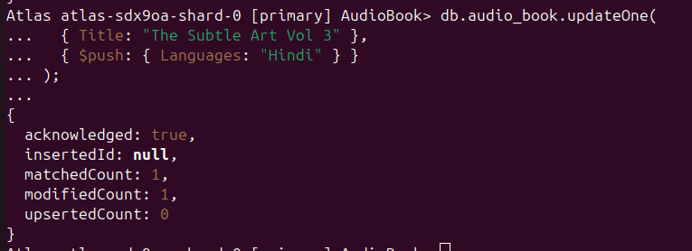
in this query, it add languages array in “ The Subtle Art Vol 3”

db.audio_book.updateMany(
{ price: { $gt: 15 } },
{ $push: { Languages: "Hindi" } }
);

This query updates the language of books that have a price greater than 15.

